The Graphics Pipeline

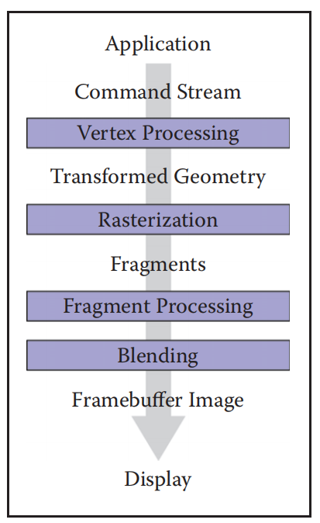

Rasterization

Rasterization is the central operation in object-order graphics, and the rasterizer

is central to any graphics pipeline.

For each primitive that comes in, the rasterizer has two jobs: it enumerates the pixels that are covered by the primitive and it interpolates values, called attributes, across the primitive.

Line Drawing

f(x, y) ≡ (y0 − y1)x + (x1 − x0)y + x0y1 − x1y0 = 0.(x0 <= x1)

slope m:

m = y1 − y0 / x1 − x0 .

Clipping

The two most common approaches for implementing clipping are

1. in world coordinates using the six planes that bound the truncated viewing

pyramid,

2. in the 4D transformed space before the homogeneous divide.

光栅化的主要工作内容

插值和裁剪